Lab3 Report

Wenqian Ye
NetID: wenqian3

- Report item 1

%H1
b1 = [2,0,5,4,0,0,-3];
a1 = [1 0];
H1 = tf(b1,a1,-1,'Variable','z^-1');
N=20;
figure(1);
subplot(121);
pzplot(H1);
subplot(122);
impz(b1,a1,N);
%H2
b2 = [3,2,0,-2];
a2 = [1 0];
H2 = tf(b2,a2,-1,'Variable','z^-1');
figure(2);
subplot(121);
pzplot(H2);
subplot(122);
impz(b2,a2,N);
%H3\
b3 = [0,0,0,1,0,0,1,-2];
a3 = [12,1,0,4];
H3 = tf(b3,a3,-1,'Variable','z^-1');
N = 20;
figure(3)
subplot(121)
pzplot(H3)
subplot(122)
impz(b3,a3,N)
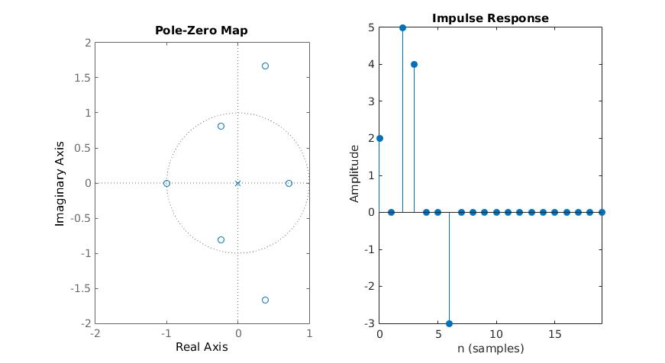
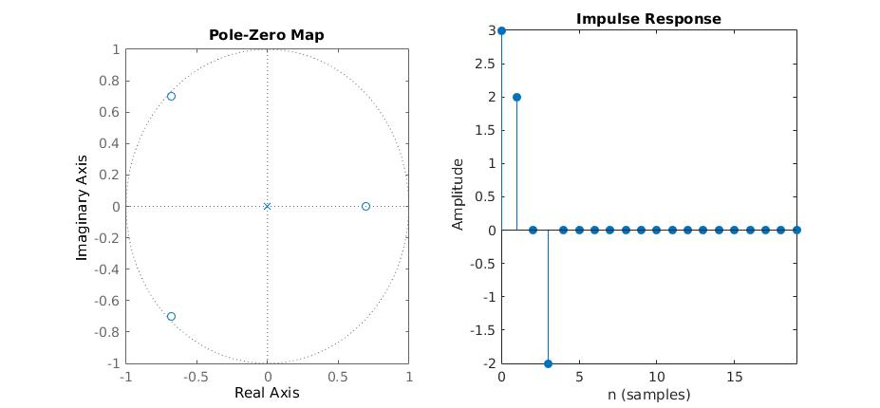
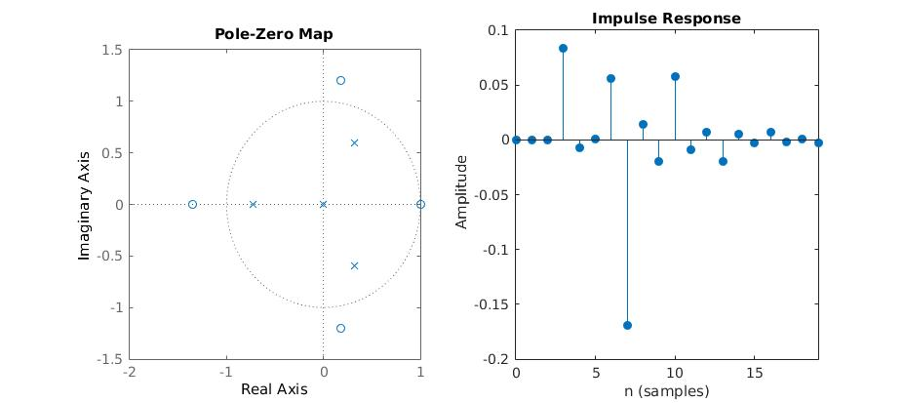

All three signals are stable because the unit circles are inside the ROC.
2.Report item 2

b = [0, 1];
a = [1,2*cos(4*pi/5),1];
H = tf(b,a,-1,'Variable','z^-1');
N = 35;
figure(1)
subplot(121)
pzplot(H)
subplot(122)
impz(b,a,N)
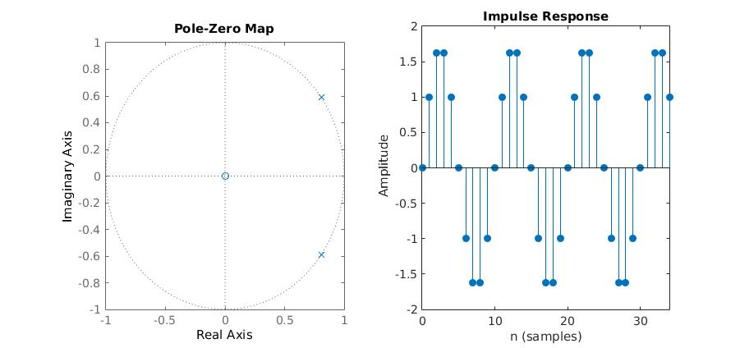
This signal is not stable the ROC doesn't contain the unit circle.

3.Report item 3

clear;
syms n z;
x(n) = ((1/2)^n + (1/3)^n)*heaviside(n);
xz1 = ztrans(x,n,z);

% xz1 =
%
% 1/(2*z - 1) + 1/(3*z - 1)
% Let's the impluse response h[n] = u[n];
% yz = xz1*hz = (1/(2*z - 1) + 1/(3*z - 1))*(1/(1-z^-1))
% b = [6 0 -1];
% a = [6 -5 1];
iztrans((1/(2*z - 1) + 1/(3*z - 1) + 1)*(1/(1-z^-1)));
%ans =

%3/2 - (1/3)^n/2 - (1/2)^n)
b = [1 0];
a = [1 -1];
n = 1:100;
x = (1/2).^n + (1/3).^n;

xz1 = 3/2 - (1/3).^n/2 - (1/2).^n;
xz2 = filter(b,a,x);
figure(1)
subplot(121);
stem(xz1,'r');
title('Inverse ztrans','fontsize', 14);
xlabel('n','fontsize',14)
ylabel('value','fontsize',14)
subplot(122);
stem(xz2,'b');
title('filter','fontsize', 14);
xlabel('n','fontsize',14)
ylabel('value','fontsize',14)
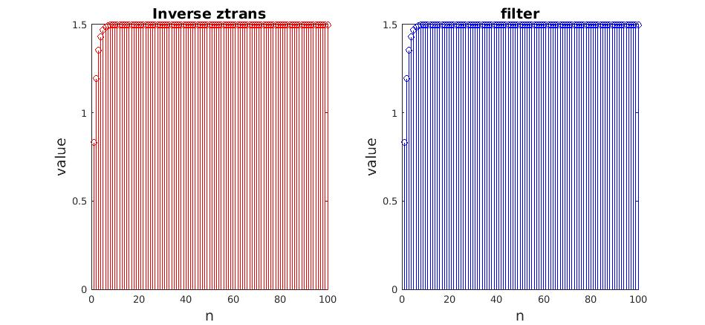
4.Report item 4

h = zeros(1,20);
h(1,1)=2;
for n =2:20
h(1,n) = -4*(1/3)^(n-1);
end
figure(1);
subplot(121);
stem(h);
x = zeros(1,20);
for n=1:20
x(1,n) = (1/2)^(n-2) ;

end
y = conv(x,h);
subplot(122);
stem(y);

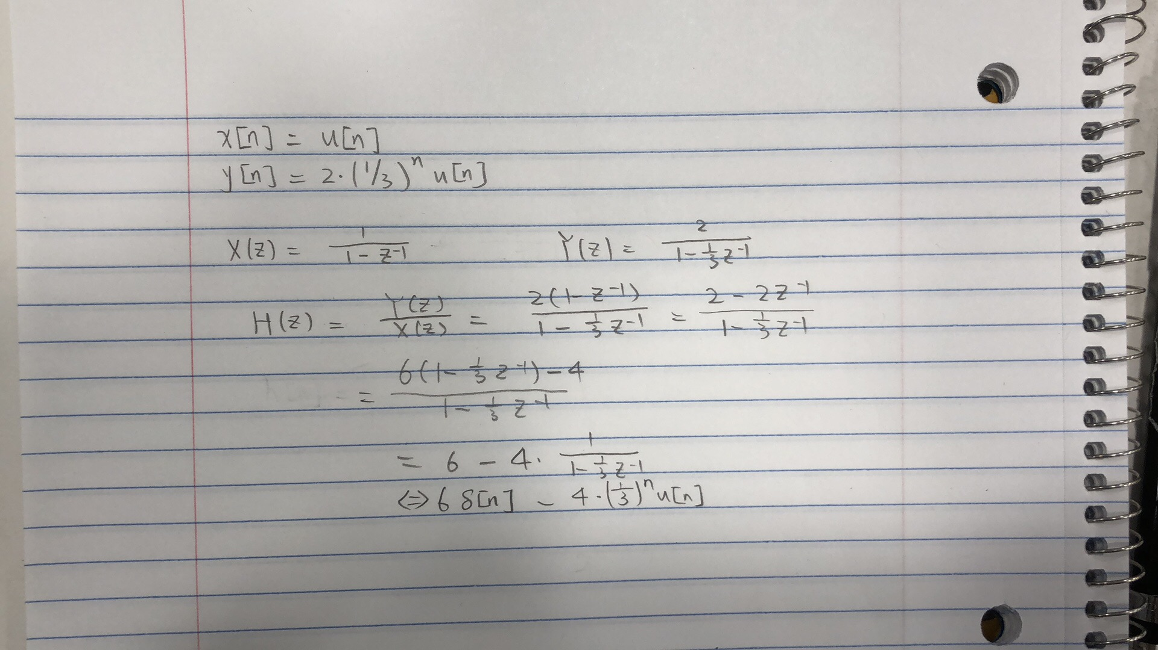
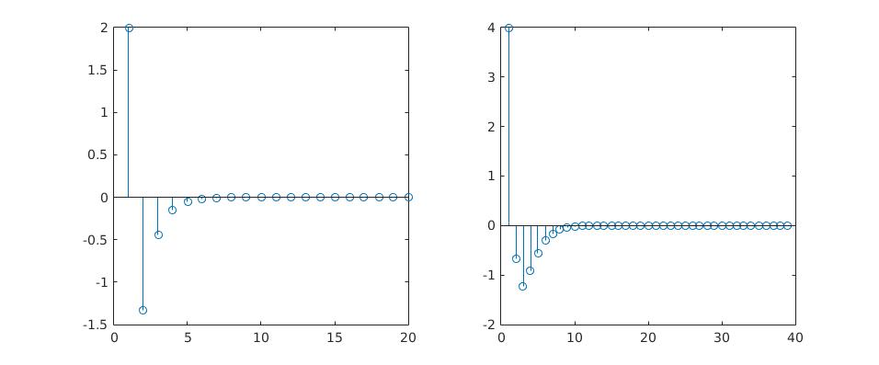

5.Report item 5

clear;
b1 = [1 0 0 0 0 0 0 0 0 0 -1/1024];
a1 = [1 -1/2];
H1 = tf(b1,a1,-1,'Variable','z^-1');
figure(1);
N=30;
subplot(121);
pzplot(H1);
subplot(122);
impz(b1,a1,N);

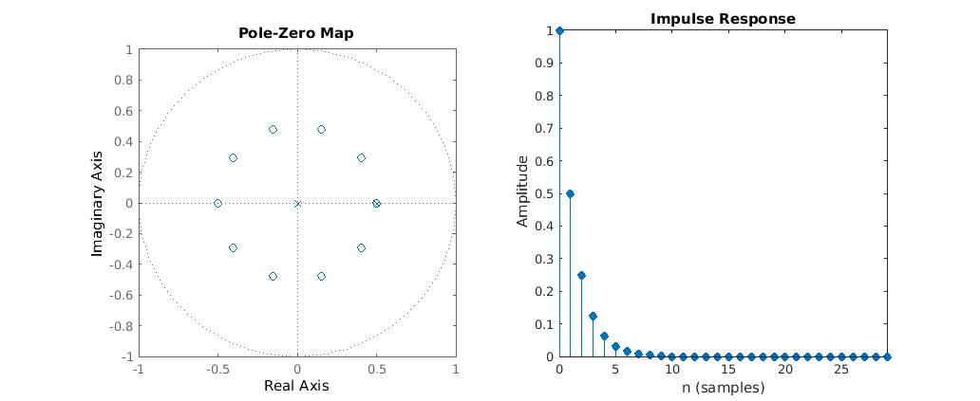

6.Report item 6
clear;
y1 = zeros(1,52);
x = zeros(1,51);
for i = 0:49
x(1,i+2) = 0.7^i;
end
for i = 0:49
y1(1,i+3) = x(1,i+2)-x(1,i+1)+0.81*y1(1,i+1);
end
figure;
hold;
subplot(121)
stem(y1(3:52),'r');
title('Recursive','fontsize', 14);
xlabel('n','fontsize',14)
ylabel('value','fontsize',14)

b1 = [1 0 -0.81];
a1 = [1 -1];
y2 = filter(a1,b1,x);
for n = 1:50
y2(n) = y2(n+1);
end
subplot(122)
stem(y2(1:50),'b');
title('Filter','fontsize', 14);
xlabel('n','fontsize',14)
ylabel('value','fontsize',14)
